Lab # 08



Fall 2024

**CSE-411L Intro to Game Development Lab**

Submitted by: MUHAMMAD SADEEQ

Registration No.: 21PWCSE2028

Section: C

“On my honor, as a student of the University of Engineering and Technology, I have neither given nor received unauthorized assistance on this academic work”

Submitted to:

Engr. Abdullah Hamid

(15 Dec 2024)

Department of Computer systems engineering

University of Engineering and Technology, Peshawar

1. **Opened or Created a Unity Scene:**
   1. Launched Unity and either created a new scene.
2. **UI Setup:**
   1. Designed a simple UI in the main menu scene, including:
   2. A Play button to transition from the current scene to the game scene (created in the previous lab).

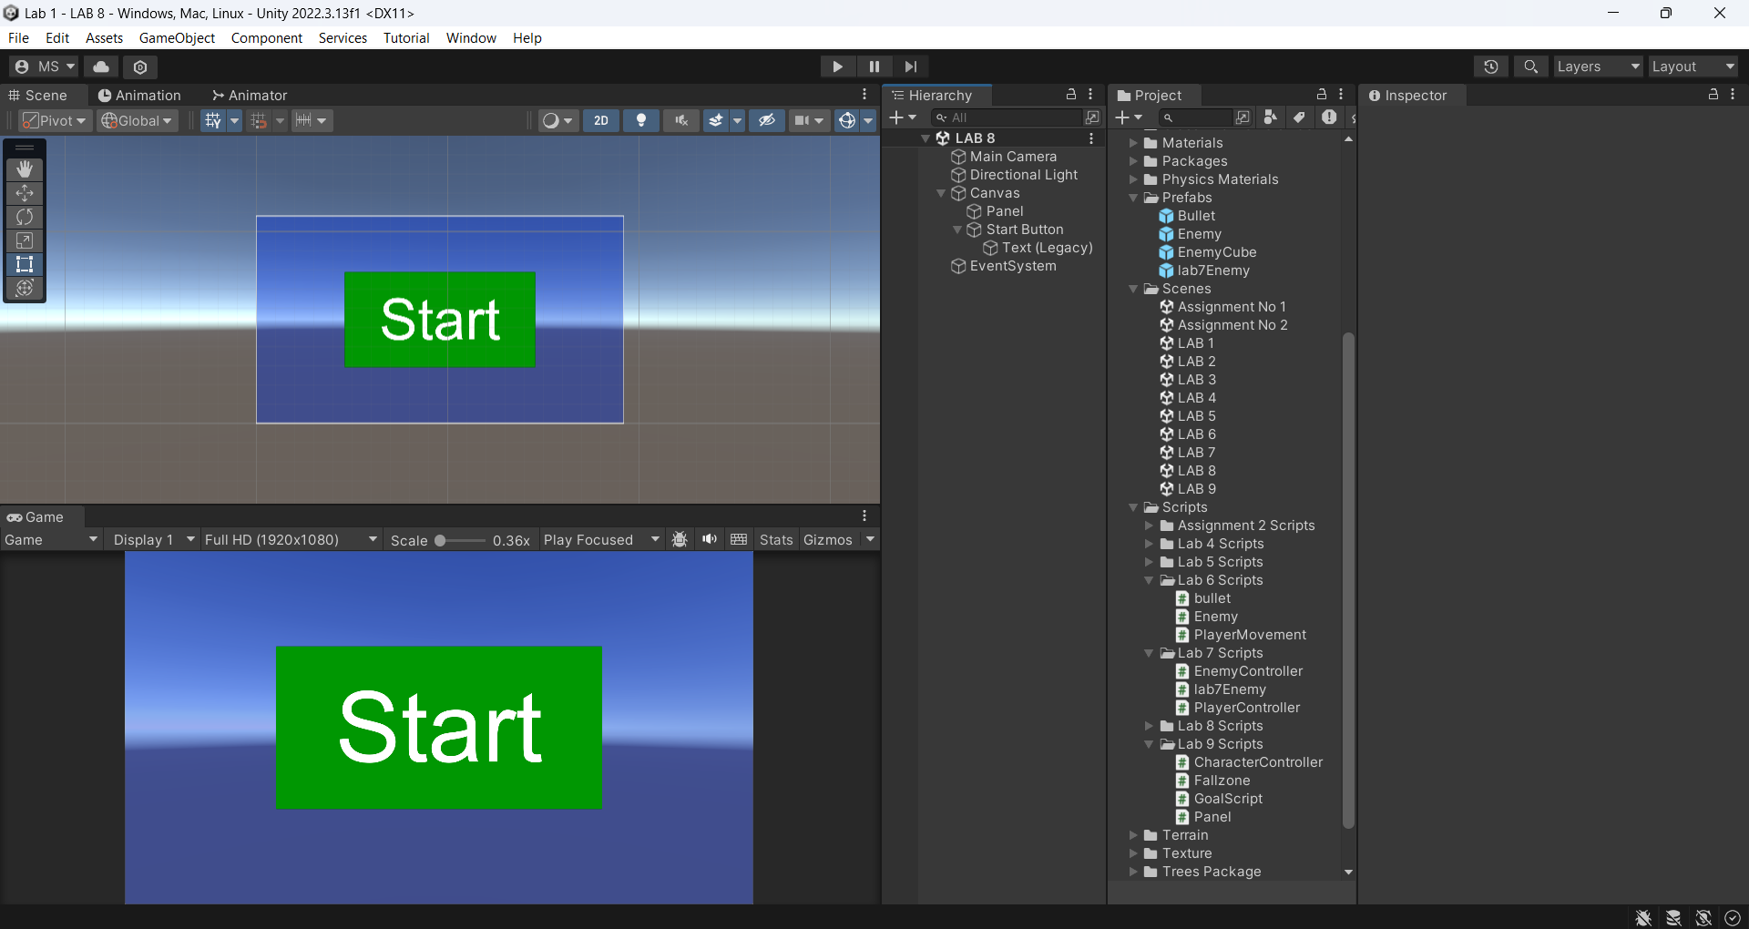

1. **Scene Transition:**
   1. Configured the Play button to close the main menu scene and load the game scene from the previous lab.

**Game Manger Code:**

using System.Collections;

using System.Collections.Generic;

using UnityEngine;

using UnityEngine.SceneManagement;

public class GameManager : MonoBehaviour

{

public void PlayGame()

{

SceneManager.LoadScene(1,LoadSceneMode.Single);

}

public void Exit()

{

SceneManager.LoadScene(0);

}

}

1. **High Score Display:**
   1. Enhanced the UI in the game scene by adding a text box to display the high score.
2. **Score Management:**
   1. Created a new script, ScoreManager.cs, with the following functionality:
   2. Defined a static integer to store the current score.
   3. Added non-static references for highScore and score to track and display values in the game.
   4. Implemented a system to manage both the score and the high score.
   5. Included a static void function to handle high score logic when the game ends, updating the high score if the current score exceeds it.

**Score Manager Code:**

using System.Collections;

using System.Collections.Generic;

using UnityEngine;

using UnityEngine.UI;

public class ScoreManager : MonoBehaviour

{

public static int highscore = 0;

public static void GameOver(int currentScore)

{

if (highscore < currentScore)

{

PlayerPrefs.SetInt("highscore", currentScore);

highscore = PlayerPrefs.GetInt("highscore");

}

}

}

1. **Game Over Panel Enhancements:**
   1. Added new buttons to the Game Over panel in the game scene:
   2. Exit Button:
   3. Returns to the main menu scene (with the Play button).
   4. Replay Button:
   5. Restarts the current game scene, resetting the score and game state.

